Advantages of TestNG over Junit

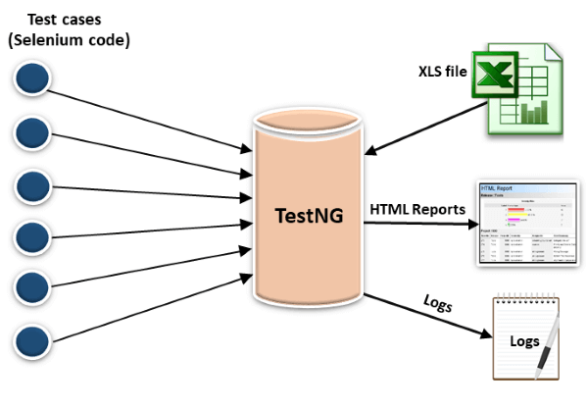

* In TestNG, annotations are easier to understand than Junit.
* It produces the HTML reports for implementation.
* It also generates the Logs.
* In TestNG, there is no constraint available such as @beforeclass and @afterclass which is present in Junit.
* TestNG enables you to group the test cases easily which is not possible in JUnit.
* TestNG supports three additional levels such as @Before/After suite, @Before/AfterTest, and Before/AfterGroup.
* TestNG does not extend any class. TestNG framework allows you to define the test cases where each test case is independent of other test cases.
* It allows you to run the test cases of a particular group. Let's consider a scenario where we have created two groups such as 'Smoke' and 'Regression'. If you want to execute the test cases in a 'Regression' group, then this can only be possible in the TestNG framework.
* Parallel execution of test cases, i.e., running multiple test cases is only possible in the TestNG framework